Single number.

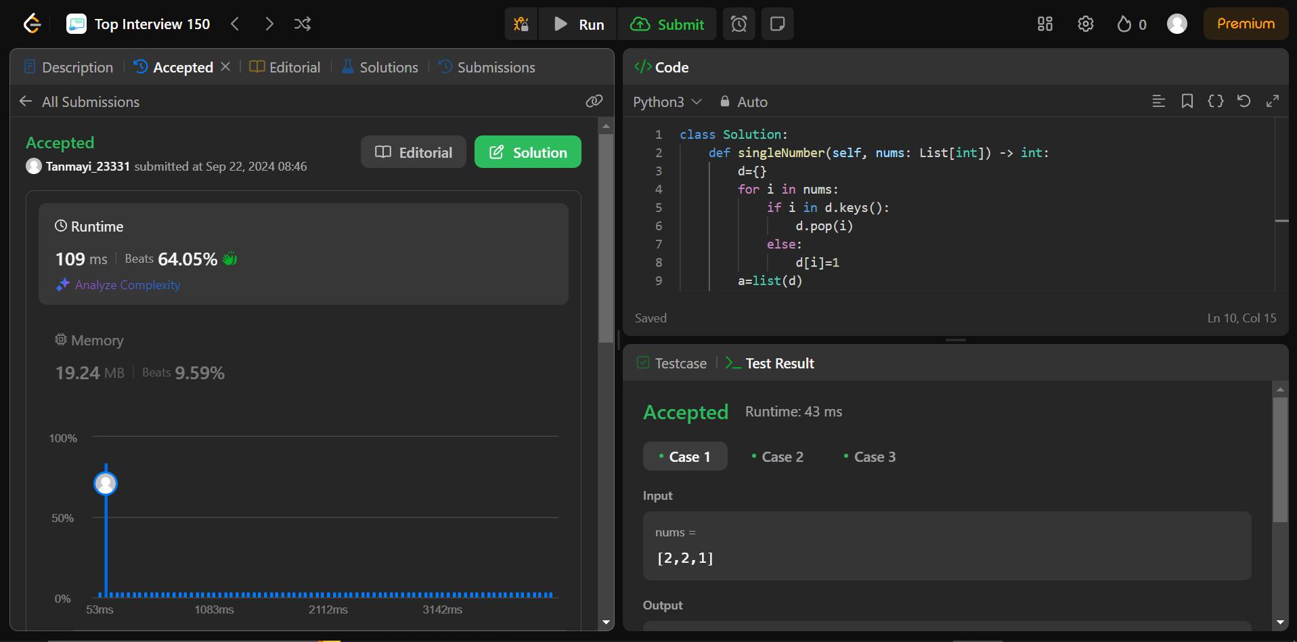

Code:

nums = [4,2,1,2,1]

d={}

for i in nums:

if i in d.keys():

d.pop(i)

else:

d[i]=1

a=list(d)

print(a[0])

Explain:

We are declaring a dictionary named d to maintain the count .here we are checking if the element already exists in the d or not .If it doesn’t exist then it added .if it exists that means that it appears twice in the array ,so we are removing the pair from d .finally I didn’t get how to print the key so I used list to get the number.